Computer Workshop 8: Linear models with interactions
Roos & Pinard
Last updated: 2024-10-03
Table of Contents

Workshop Structure
As always, we’re using our tried-and-tested workflow to guide today’s workshop:
- Formulate a research question.
- Perform exploratory data analysis (EDA).
- Identify any hidden assumptions.
- Fit an appropriate model [today’s main focus].
- Diagnose the model and check assumptions.
- Summarise the results.
- Interpret and draw conclusions.

1. Formulate a Research Question
For this last workshop on incorporating explanatory variables in linear models, we’re going to be using a dataset from a study set in the coral reef ecosystems of the “Coral Triangle”, a biodiversity hotspot located in the Indo-Pacific region (called reef.txt on MyAberdeen). The data includes:
- Shark Density: Tiger shark (Galeocerdo cuvier) density, estimated using underwater visual surveys conducted by divers along transects at each site. Densities were recorded as the number of sharks observed per square kilometer.
- Reef Complexity: Reef complexity was assessed using a “standardized structural complexity index”, which incorporates how much area is covered by coral, “rugosity” (i.e. surface roughness), and habitat diversity. Higher scores represent more structurally complex reefs.
- Fish Biomass Change: Fish biomass change was measured as the net difference in biomass (kg/m$​^{2}$) over a six-month period using underwater cameras. Changes could be positive (population growth) or negative (population decline).
Our research objective (or question) is to predict fish biomass change as shark density and reef complexity change.

2. Perform Exploratory Data Analysis (EDA)
As usual, spend a few minutes exploring the dataset. Check for any obvious errors or odd values.

3. Identify Any Hidden Assumptions
Once you’ve carried out an EDA, spend some time thinking about the data and any hidden assumptions that are made when using it.

4. Fit an Appropriate Model
We’ll start with a model that does not include any interaction between our two continuous explanatory variables. The statistical notation for this model is:
$biomass_{i}∼Normal\left(μ_{i},σ\right)$
$μ_{i}=β_{0}+β_{1}×shark_{i}+β_{2}×reef_{i}$
Where:
- $β_{0}$ is the intercept, representing the change in biomass when there are no sharks and reef complexity is zero.
- $β_{1}$ is the slope for each additional tiger shark density.
- $β_{2}$ is the slope for each additional reef complexity measure.
Let’s run the model:
bio_mod <- lm(biomass_change ~ shark_density + reef_complexity, data = reef)

5. Diagnose the model and check assumptions.
As always, having run a model, let’s check our residuals to see how well they meet our assumptions:
par(mfrow = c(2,2))
plot(bio_mod)
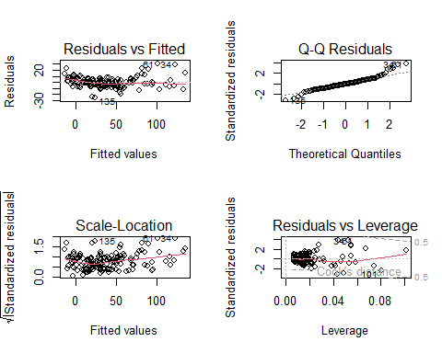
par(mfrow = c(1,1))

Question Set One
- Do any assumptions cause concern?
# Yes, the residuals vs fitted plot seems to have a slightly weird pattern. Here, it's indicating that either the assumption of validity or additivity are possibly violated.
# The other plots look ok.

6. Summarise the results.
Now let’s take a look at the estimated parameters using summary():
summary(bio_mod)

Question Set Two
- How much does predicted biomass change for each additional shark density?
# By 3.2 kg for each additional density
- How much does predicted biomass change for each additional reef complexity measure?
# By 7.1 kg for each additional reef complexity
- How much do you predict biomass would change, if shark density was 5 and reef complexity was 0.1? What about if there were 10 sharks and reef complexity was 0.1?
# We can either do this by hand, or use R. Using R, we'd do this using:
new_shark <- 5
new_reef <- 0.1
-27.2075 + 3.2171 * new_shark + 7.1169 * new_reef
# We'd predict biomass would change by: -10.41031 kg under these conditions
new_shark <- 10
new_reef <- 0.1
-27.2075 + 3.2171 * new_shark + 7.1169 * new_reef
# We'd predict biomass would change by: 5.67519 kg under these conditions
- From your answer to Q3, what does going from five to ten sharks do for predicted biomass?
# Having an extra five sharks (from five to ten) apparently increases biomass by roughly 16 kg
Let’s use ggeffects to quick make a plot:
library(ggeffects)
## Warning: package 'ggeffects' was built under R version 4.3.3
preds <- ggpredict(bio_mod)
plot(preds)
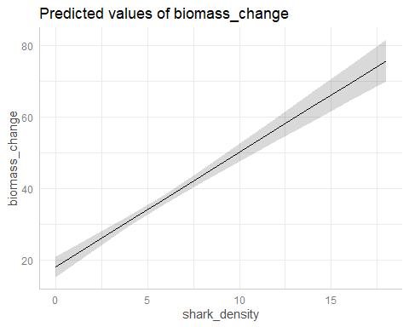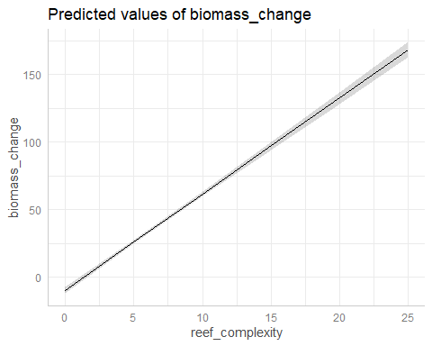

7. Interpret and draw conclusions.

Question Set Three
- How would you explain the apparent result where sharks cause biomass to increase?
# It's kind of hard to think why adding predators would increase the number of prey. But not impossible. Maybe it's because adding more predators cause some kind of trophic cascade, or some kind of "landscape of fear" effect, shifts in species compositions, compensatory breeding by prey, etc, etc,.
# The point is that you can always come up with some hypothesis to explain your results. It's something called "HARKing" (or Hypothesising After Results Known), and is a serious problem in science. To be very clear, HARKing is a *highly* questionable research practice (i.e. essentially fraud) where researchers try to explain their results, after their model tells them the answer, while pretending that they were always testing this hypothesis. You'll see later why this is very dangerous and should never be done.

Including an Interaction
The model we’ve just run only includes so called “main effects”, i.e. just shark density and reef complexity where the effects of both are independent of the other. For example, the model doesn’t account for scenarios such as if we added a million sharks to the system, in which case the reef complexity is probably not going to matter.
But thinking about this logically, it seems pretty likely that the effects of shark might be more pronounced if a reef is very simple (i.e. lots of predators and not many places to hide), while the same number of sharks in a more complex reef might be less important (i.e. lots of predators but lots of places to hide). How do we go about including this “combined effect”? Through an interaction.
The good news is that interactions are easy to incorporate into our model and there are two ways to do it. The first is:
biomass_change ~ shark_density + reef_complexity + shark_density : reef_complexity
where we have the same “main effects” of shark and reef, but now include the multiplied (or “combined” or “interacting” effects) by using the :. Or we can write the exact same model by doing:
biomass_change ~ shark_density * reef_complexity
which is exactly the same as above, except that we have a more condensced version of the code.
No matter how we specify the interaction, the resulting statistical notation for this model takes the same form.

Question Set Four
- Complete the following equation to include the statistical notation:
$biomass_{i}∼Normal\left(μ_{i},σ\right)$
μi=β0+β1×sharki+β2×reefi+β3×sharki×reefi
Where:
- $β_{0}$ is the intercept, representing the change in biomass when there are no sharks and reef complexity is zero.
- $β_{1}$ is the slope for each additional tiger shark density.
- $β_{2}$ is the slope for each additional reef complexity measure.
- $β_{3}$ is combined (or interacting) slope for both sharks and reef complexity.
# The completed equation is:
# biomass_i ~ Normal(mu_i, sigma)
# mu_i = beta_0 + beta_1 * shark_i + beta_2 * reef_i + (beta_3 * shark_i * reef_i)
# Note that the brackets around the interaction are not strictly needed but can help readers to spot the interaction
Once done, run the model with an interaction between shark density and reef complexity:
# Using the simpler R syntax to include the interaction
bio_mod <- lm(biomass_change ~ shark_density * reef_complexity, data = reef)
Given we’ve run a new model, we need to check our assumptions related to residual errors:
par(mfrow = c(2,2))
plot(bio_mod)
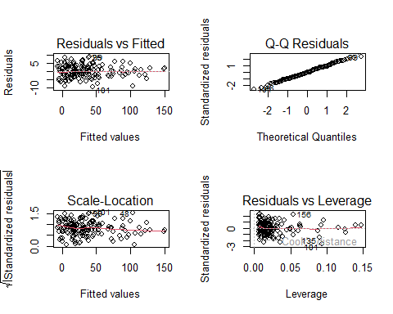
par(mfrow = c(1,1))

Question Set Five
- Does the model with the interaction resolve the concerns we had from the model with only main effects?
# Yes - the diagnostics look excellent now. This would give some evidence that the first model was violating the assumption of additivity.
- Does meeting these assumptions make a model inherently trustworthy?
# No, it just means we've not been able to find any issues related to residual errors, plus we can't check for hidden assumptions with these plots.
If you’re happy with the model (i.e. you don’t find anything that explicitly says you should not trust the model), let’s move on to summarising and interpreting the model, starting with summary():
summary(bio_mod)

Question Set Six
- What does the intercept ((Intercept), or $β_{0}$) represent now?
# Our intercept still represents the predicted biomass change when there are zero sharks and reef complexity is zero.
- What does the interaction (shark_density:reef_complexity, or $β_{3}$) represent?
# This is our interaction, which is the combined effect of both shark density and reef complexity changing, beyond the simple "main effects". This tells you how much you would predict biomass will change as *both* shark density and reef complexity change.
- Do we still find that increasing shark density has a positive effect on biomass?
# No, we get something that seems far more intuitive and requires fewer mental gymnastics to explain. Predators eat prey. The more predators the less prey. Just that simple.
- What does the interaction being positive tell you about the system?
# It suggests that the negative impact of sharks on prey biomass is reduced in more complex reefs, which we might interpret as meaning the more places there are for prey to hide, the less "effective" sharks are at catching prey.

Visualising interactions
When visualising how different combinations of explanatory variable values affect a response, you need to create a dataset that covers all possible combinations of your predictors. Previously we used data.frame() to create our fake datasets, but here we’ll need to use the function expand.grid().

What is expand.grid()?
The expand.grid() function in R is used to generate a data frame from all possible combinations of the supplied variables. It’s particularly useful when you want to create a grid of predictor values to simulate and visualize interactions. How does it work? Well, imagine you have two variables:
- Shark Density (e.g., shark_density)
- Reef Complexity (e.g., reef_complexity)
We want to visualise how the interaction between these two variables affects a response, such as biomass change. To do this, you need to create a dataset with all combinations of values for these predictors.
Here’s how expand.grid() helps:
- Create Sequences of Values: First, define the range of values for each predictor. For example, a sensible range for shark density would be from the minimum shark density to the maximum. And the same for reef complexities. You can use the seq() function to generate these sequences.
shark_density_seq <- seq(from = min(reef$shark_density),
to = max(reef$shark_density),
by = 1)
reef_complexity_seq <- seq(from = min(reef$reef_complexity),
to = max(reef$reef_complexity),
by = 1)
- Generate Combinations: Use expand.grid() to create a data frame that contains every possible combination of these sequences. Note that it’s important that your variables are named the same as in the original dataset.
fake <- expand.grid(
shark_density = shark_density_seq,
reef_complexity = reef_complexity_seq
)
In this example:
- shark_density takes on each value from shark_density_seq.
- reef_complexity takes on each value from reef_complexity_seq.
- expand.grid() produces a data frame where each row represents a unique combination of both of these variables.
If you want to see what this fake dataset looks like run head(fake).
Once we have this fake dataset with all combinations of shark density and reef complexity, we can use it to make our figure. For visualising interactions between two continuous variables, one of the more effective ways is to use a heatmap, where color represents the response variable (here biomass change). In ggplot2, we can create this type of plot using geom_tile(). In a heatmap, the x-axis represents one predictor (e.g., shark density), the y-axis represents the other predictor (e.g., reef complexity), and the fill color represents the predicted response (e.g., biomass change).
Here’s how we can create a heatmap figure that shows our results using the model with an interaction:
fake$fit <- predict(bio_mod, newdata = fake)
ggplot(fake) +
geom_tile(aes(x = shark_density, y = reef_complexity, fill = fit)) +
labs(x = "Shark Density",
y = "Reef Complexity",
fill = "Predicted Biomass Change") +
theme_minimal()
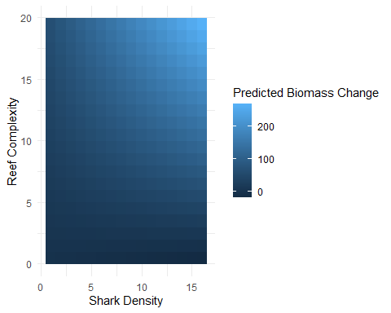
Plotting it now allows us to see the interaction. We can see that the greatest biomass occurs at high reef complexity and also high shark density, which we will now need to try and rationalise (without “HARKing”, or pretending that we always thought this result was going to be the case) which this might be the case.
There are two problems with our figure above. The first is that the blue gradient can be hard to distinguish, so we might want to change to another colour palette.
The second, and more serious, is that it’s really hard to effectively convey uncertainty with heatmaps. A trick some people use is to make two additional figures, one showing the upper 95% CI and the other showing the lower 95% CI. However, these aren’t great options. It’s really hard for our eyes to “match up” the same area of multiple heatmaps with each other, so you don’t really get a precise understanding of what the uncertainty is, for a specific location.
If you have any bright ideas for how to effectively convey uncertainty with heatmaps (or even just maps), then you might have a great paper! We’re not aware of anyone that’s found a particularly compelling way of doing this yet.
Easier than the second problem, we can solve the problem of colour palettes pretty easily in ggplot2, simply by saying we want to use a different palette, using scale_fill_viridis_c() (or the viridis colour palette). My preferred option is:
ggplot(fake) +
geom_tile(aes(x = shark_density, y = reef_complexity, fill = fit)) +
scale_fill_viridis_c(option = "magma") +
labs(x = "Shark Density",
y = "Reef Complexity",
fill = "Predicted Biomass Change") +
theme_minimal()
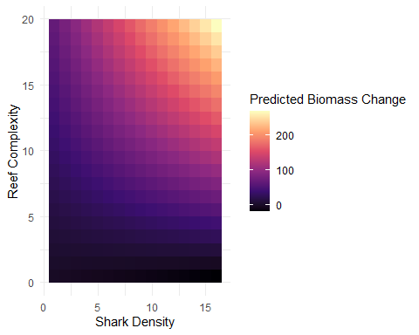

A New Challenger
Having gone through this process, if there’s time, analyse the following dataset on Asian elephants in the context of human-wildlife-conflicts (called elephants.txt on MyAberdeen). This dataset contains elephant activity with varying vegetation cover and proximity to human settlements. The researchers are interested in how these factors might interact to influence elephant behavior, focusing on the idea that elephants should show higher activity levels in undisturbed natural areas.
The dataset includes:
- Vegetation Cover (continuous, 0-100%): Represents the density of vegetation at different sites.
- Proximity to Human Settlements (categorical, 3 levels: “Far”, “Near”, “Very Near”): Indicates how close each site is to human activity.
- Activity Index (response variable): Reflects differences from an assumed “baseline activity level” observed in elephants present in an undisturbed, dense vegetation area. Negative values suggest reduced activity relative the this undisturbed locations, while positive values indicate an increase in activity.
Go through the process of analysing this dataset to predict if elephants are more or less active based on proximity to towns and vegetation cover (and their interaction). Consider how best to visualise your results and create a figure that is able to effectively do so.
# This is how I would analyse the elephant data
# Deon Roos
# Analysis of elephant activity by proximity to towns and vegetation cover
# Interaction between proximity and vegetation deemed likely
# Packages -------------------------------------
library(ggplot2) # For plotting
library(ggeffects) # For quick plotting of model fit
# Data -----------------------------------------
# (Not running these here because of how this document is created)
# setwd(H:/BI3010/)
# eleph <- read.table("elephants.txt", header = TRUE)
# EDA ------------------------------------------
# No issues found during EDA
str(eleph)
# n = 201
summary(eleph)
# No apparent issues
ggplot(eleph) +
geom_density(aes(x = activity)) +
theme_minimal()
ggplot(eleph) +
geom_density(aes(x = activity, fill = prox_town),
alpha = 0.5) +
theme_minimal()
ggplot(eleph) +
geom_boxplot(aes(y = activity, x = prox_town)) +
theme_minimal()
ggplot(eleph) +
geom_point(aes(y = activity, x = veg_cover)) +
theme_minimal()
ggplot(eleph) +
geom_point(aes(y = activity, x = veg_cover, colour = prox_town)) +
facet_wrap(~prox_town) +
theme_minimal()
# Figure above implies interaction very likely
# Hidden assumption ----------------------------
# - Validity - Activity is compared to a "baseline" activity. Activity variable in general pretty vague. Would want more clarification on this variable from data collectors.
# - Representativeness - Not entirely clear to me what this data represents, given activity of a herd is compared to baseline of elephants in "pristine" environment.
# Model fit ------------------------------------
el_mod <- lm(activity ~ veg_cover * prox_town, data = eleph)
# Diagnose -------------------------------------
par(mfrow = c(2,2))
plot(el_mod)
par(mfrow = c(1,1))
# All in all, pretty good diagnostics. Nothing to be concerned about.
# Summarise ------------------------------------
summary(el_mod)
# All parameters are difference in observed herds from elephants in a "pristine" environment
# FAR AWAY PARAMETERS --------------------------
# Model predicts 6.1 more hours of activity when elephants far away and 0% vegetation cover (compared to pristine)
# When herds are Far away from towns, every additional percent of vegetation increases activity by 0.08 hours
# NEAR PARAMETERS ------------------------------
# When herds are near to towns, they are active for 6.3 hours *less* compared to Far away
# For additional vegetation cover, they spend 0.12 *less* compared to the equivalent cover for Far elephants
# VERY NEAR PARAMETERS -------------------------
# When herds are very near, they are active for 9.7 hours *less* compared to Far away
# For additional vegetation, the spend 0.21 *less* hours compared to the herds that are Far away
# Main effects plots
preds <- ggpredict(el_mod)
plot(preds)
# Interaction plot
preds <- ggpredict(el_mod, terms = c("veg_cover", "prox_town"))
plot(preds)
# Interpret -----------------------------------
# When elephants are far away from towns, the number of hours they are active for increases as vegetation cover increases, compared to the baseline levels of activity researchers had on elephants in "pristine" environments.
# This changes when elephants are deemed "near" or "very near" to towns, whereby they are less active with increasing vegetation cover.
# This may indicate that elephants attempt to avoid conflict with humans.

Assumption table
Assumption | Description | Example of Violation
1. Validity | The data is able to answer the research question effectively. | Using IQ to measure overall intelligence (what does IQ even measure?).
2. Representativeness | The data reflects the population or group being studied. | Using survey data from a rural area to draw conclusions about an urban population.
3. Additivity | Effects of predictors are additive and there are no interactions between them. | Assuming that study hours and sleep hours independently affect exam scores without considering their combined effect (imagine a Venn diagram with study and sleep overlapping).
4. Linearity | The relationship between predictors and the outcome is linear. | Assuming plant growth will continue to increase indefinitely without ever levelling out.
5. Independence of Errors | Observations are independent of each other. (Related to residual errors.) | If modelling height, the data come from the same group of children over time.
6. Equal Variance of Errors | Residuals have constant variance across all levels of predictors (“homoscedasticity”). (Related to residual errors.) | If modelling income, variability in salaries is not the same across all levels of a company’s hierarchy.
7. Normality of Errors | Residuals should be normally distributed. (Related to residual errors.) | If modelling income, the presence of any extremely wealthy individuals will be hard for the model to understand and explain.

